**Excel Assignment – 11**

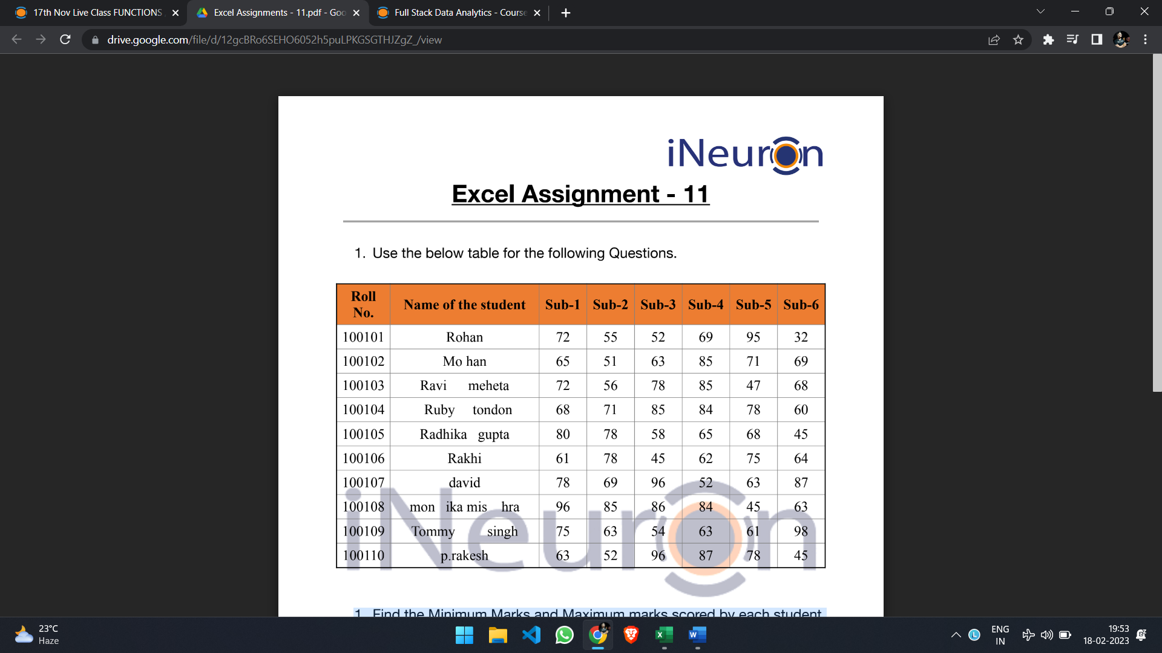

**1. Find the Minimum Marks and Maximum marks scored by each student.**

Formula used: =MIN(C2:H2)

=MAX(C2:H2)

**2. Calculate the totals for each student, use conditional formatting to highlight the top students who have scored more than 480.**

Formula used: =SUM(C2:H2)

No student scored more than 480.

**3. Calculate the length of the names of each student.**

Formula used: =LEN(B2)

**4. Replace the Name Rakhi with Rocky. Use Formulas.**

Formula used: =REPLACE(B7,1,5,"ROCKY")

**5. Combine the Roll Numbers and Names. Use formulas. The end result should look like below.**

**100101Rohan**

Formula used: =CONCATENATE(A2,B2)

**6. As you can see that some names have spacing issues. Use Formulas to correct that spacing. Also ensure that the names and surnames start with a capital letter.**

Formula used to trim the extra space: =TRIM(B2)

Formula used to ensure name and surname starts with capital letter: =PROPER(O2)

**Result:**

